**6.CREATE A SIMPLE WEB SITE USING ANY PUBLIC CLOUD SERVICE**

**PROVIDER (AZURE/GCP/AWS) AND CHECK THE PUBLIC ACCESSIBILITY OF**

**THE STORED FILE TO DEMONSTRATE STORAGE AS A SERVICE AIM:**

**Procedure:**

**IMPLEMENTATION:**

**STEP1: FIRSTLY GO TO APPSERVICE TO CREATE AN WEBAPP.**

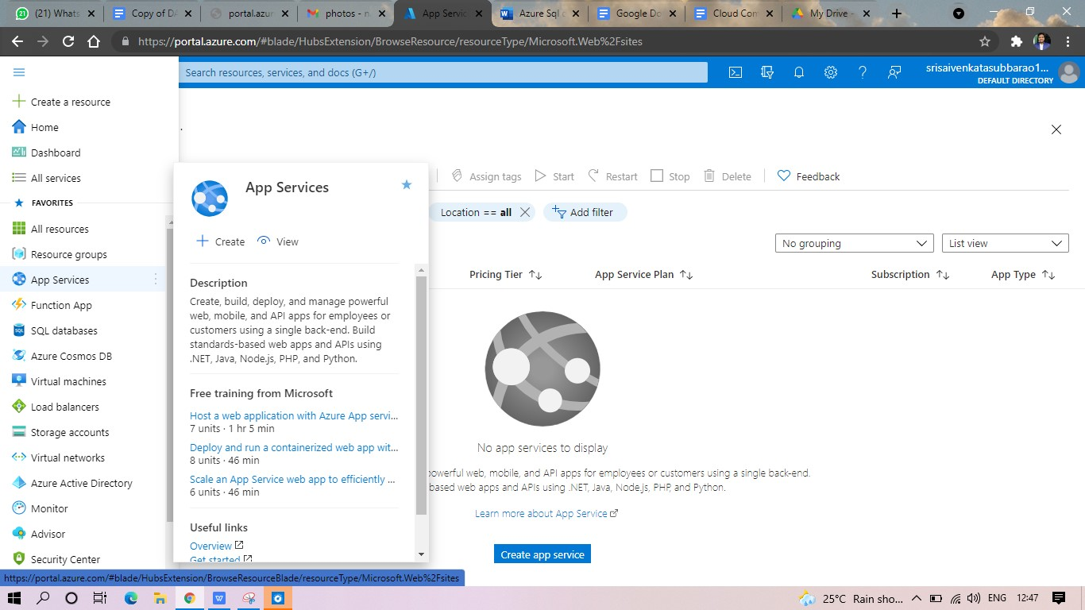

**STEP2: ENTER THE RESOURCE GROUP AND WEBAPP NAME AND REGION AND SELECT THE LINUX OS.**

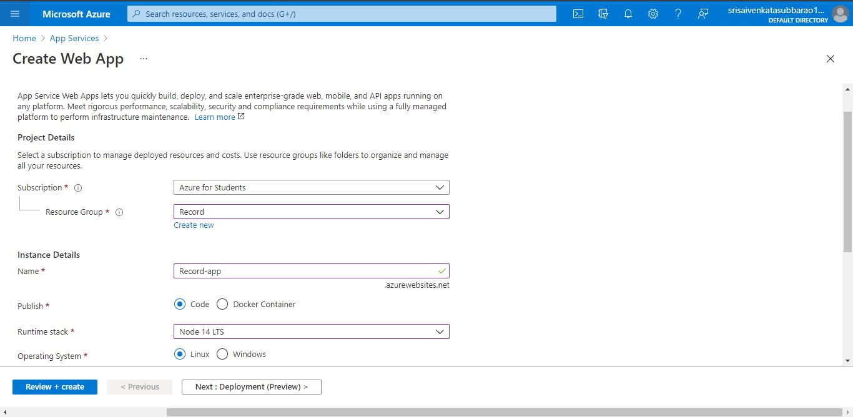

**STEP3: AFTER ENTER THE ALL THE NECESSARY THINGS CLICK THE REVIEW AND CREATE AND CLICK THE CREATE THE WEB APP.**

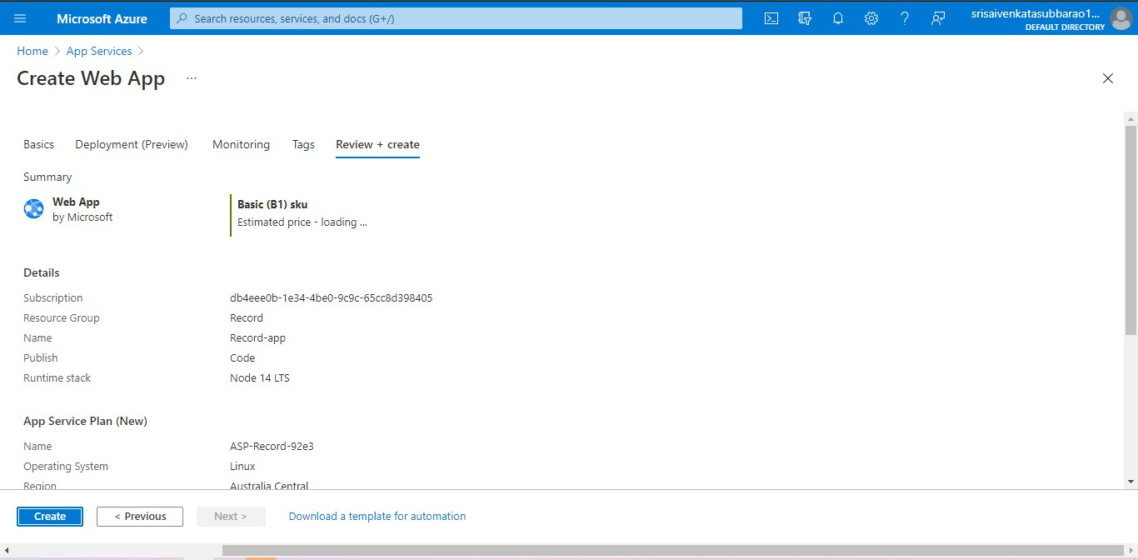

**STEP4: AND OUR DEPLOYMENT IS COMPLETED.**

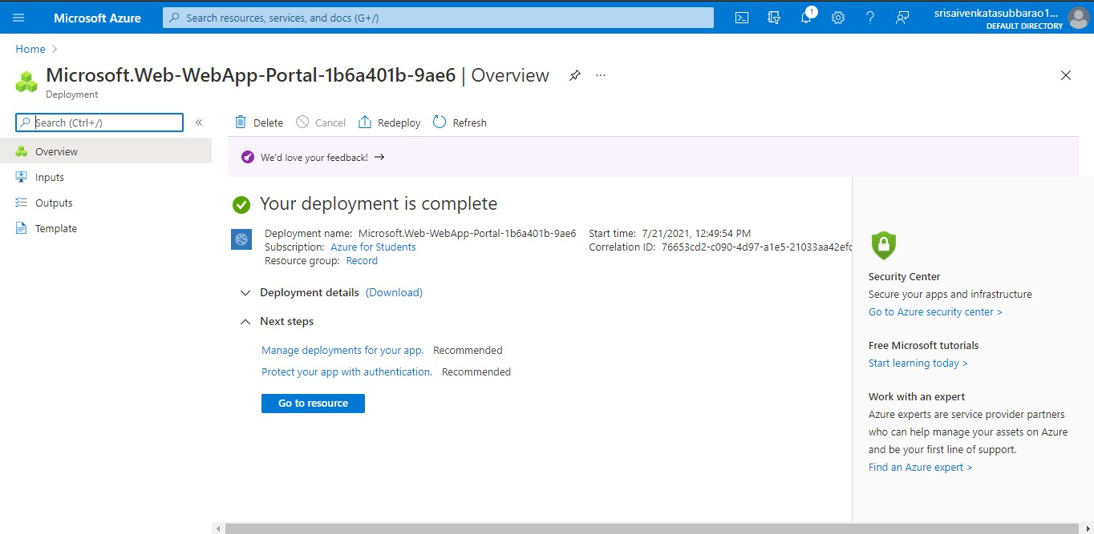

**STEP5: GOTO WEBSITE URL LINK.**

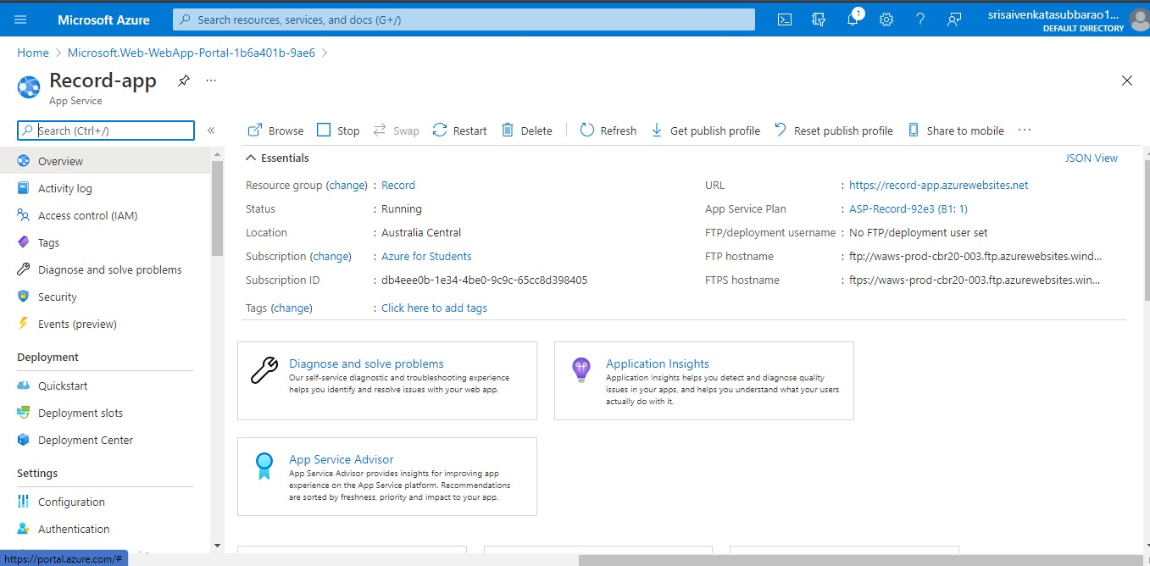

**STEP6: THIS IS OUR WEBAPP SERVICE.**

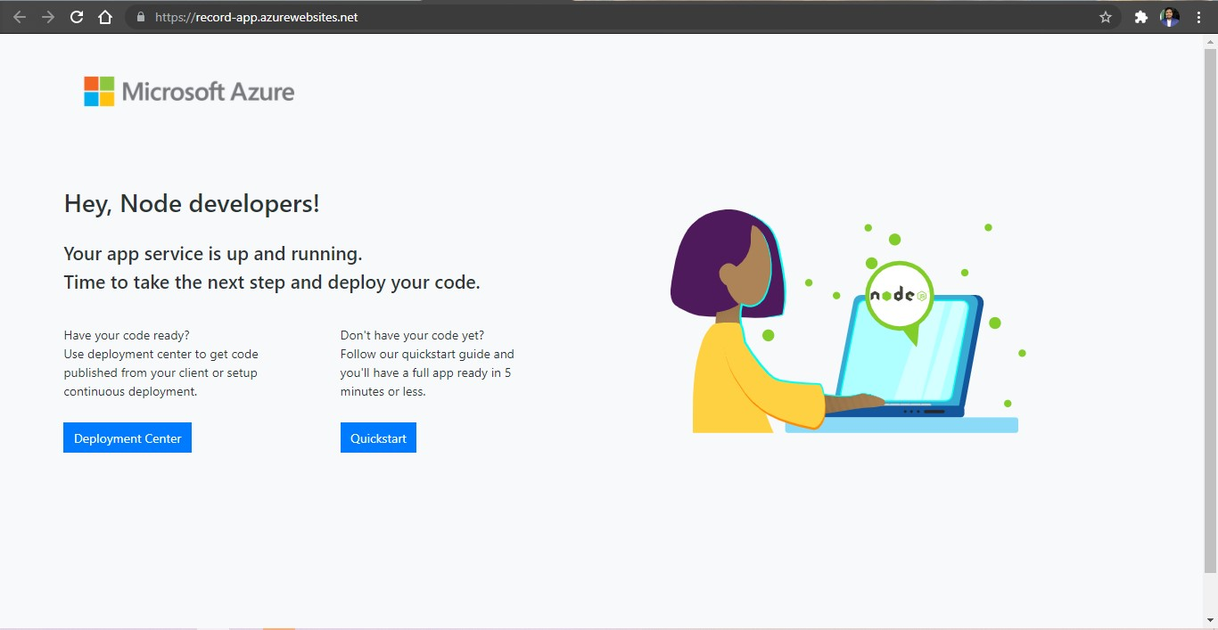

RESULT